Practice | Momentum and Impulse
- A deer with mass 146 kg runs toward you with a speed of 17 m/s. Find the momentum of the deer.
- A 21 kg child on a 5.9 kg bike is riding with a velocity of 4.5 m/s
  - What is the momentum of the child?
  - What is the momentum of the bike?
  - What is the total momentum of the child-bike system?
- At what velocity must a 1210 kg car travel to have a momentum of 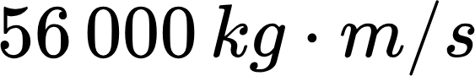?
- A 0.50 kg football is thrown with a velocity of 15 m/s. A stationary receiver catches the ball and brings it to rest in 0.020 s.
  - What is the force exerted by the receiver on the ball?
  - Should this force be considered positive or negative? Why?
- A 2.5 kg object is at rest. A 3.00 N force to the right acts on the object during a time interval of 1.50 s.
  - What is the final velocity of the object after this force is applied?
- The velocity-time graph of a 1 500 kg car is shown below.
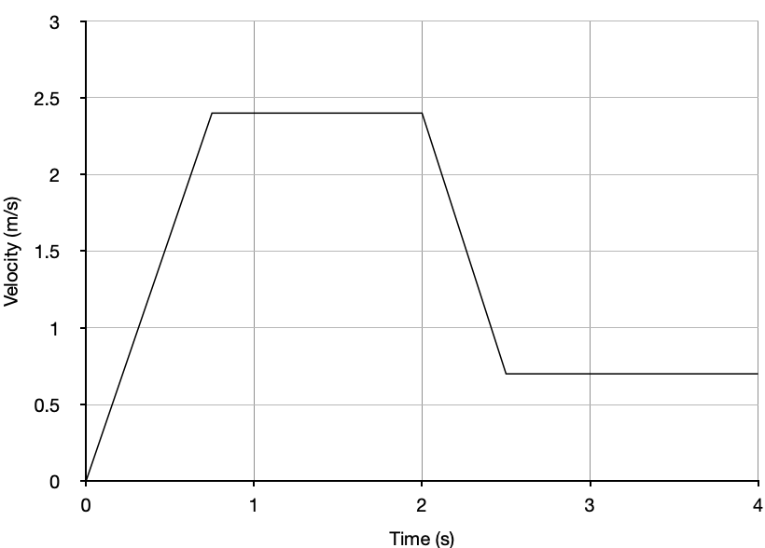
  - Calculate the momentum after its initial acceleration.
  - Calculate the force that caused the vehicle’s acceleration
  - Calculate the impulse of the vehicle’s acceleration.
  - Calculate the force that caused the vehicle to slow down

Answer Key
- 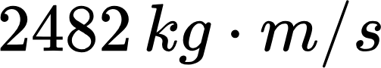
- (a) 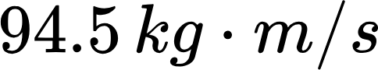
(b) 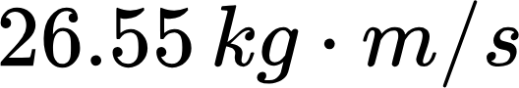
(c) 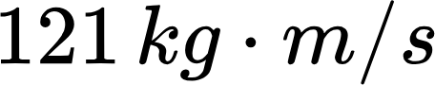
- 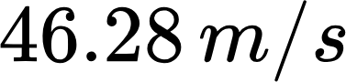
- (a) 
(b) negative, it is a stopping force and opposite direction of motion
- 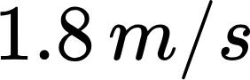
- (a) 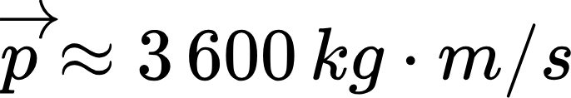
(b) 
(c ) 
(d) 

